Smile Stars India — System Architecture & Data Flow
Created by: Jazeel Jabbar
Date: 10 Aug 2025
Project: Smile Stars India — Preventive Dental Care Management Platform

Overview
This document contains a recommended enterprise-grade system architecture and data flow for the Smile Stars India platform. It includes high-level architecture diagrams, a data flow diagram, component responsibilities, recommended technology choices, non-functional concerns (security, scaling, offline support), and implementation notes for QR scanning, approvals, notifications, and content portal.

1. Architecture Summary
The system is organized into the following broad layers:
- Client Layer
  - Central Web Portal (Smile Stars India team)
  - Franchisee Web Portal
  - School Web Dashboard
  - Mobile App for franchisees & field staff (Android/iOS)
  - Doctor/Technician Mobile App (offline-capable)
  - Parent Web/Mobile-optimized view (secure links)
- API / Backend Layer
  - API Gateway / Load Balancer
  - Microservices (Auth, User & Org, Camp Management, Screening, Scheduling, Content, Notifications, Reporting)
  - Background Workers / Job Queue (for PDF/ID generation, reports, batch notifications, sync)
- Data Layer
  - Primary relational DB (Postgres) for transactional data
  - NoSQL / Document store (MongoDB) for content, logs, and flexible data
  - Object Storage (S3-compatible) for media, ID card PDFs, and exported reports
  - Search index (Elasticsearch/OpenSearch) for fast record lookup
- Integration & External Services
  - SMS Gateway
  - WhatsApp Business API
  - Email Provider (SES, SendGrid, etc.)
  - Payment Gateway (if fees involved)
  - QR generation service (or library) and barcode scanner support in app
  - Analytics & Monitoring (Sentry)
- Infrastructure & CI/CD
  - Kubernetes (GKE) or managed App Service
  - CI/CD pipeline (GitHub Actions / GitLab CI )
  - CDN for content portal media distribution
  - WAF and managed DB instances

2. High-Level System Architecture Diagram (Mermaid)

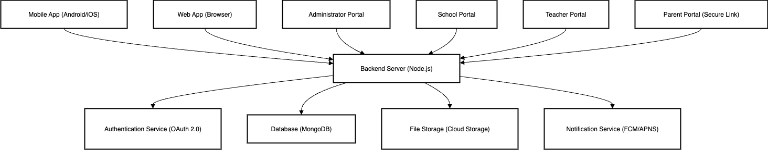

3. Data Flow Diagram (Mermaid)
This shows the main flow for camp creation → approvals → screening → parent notification.
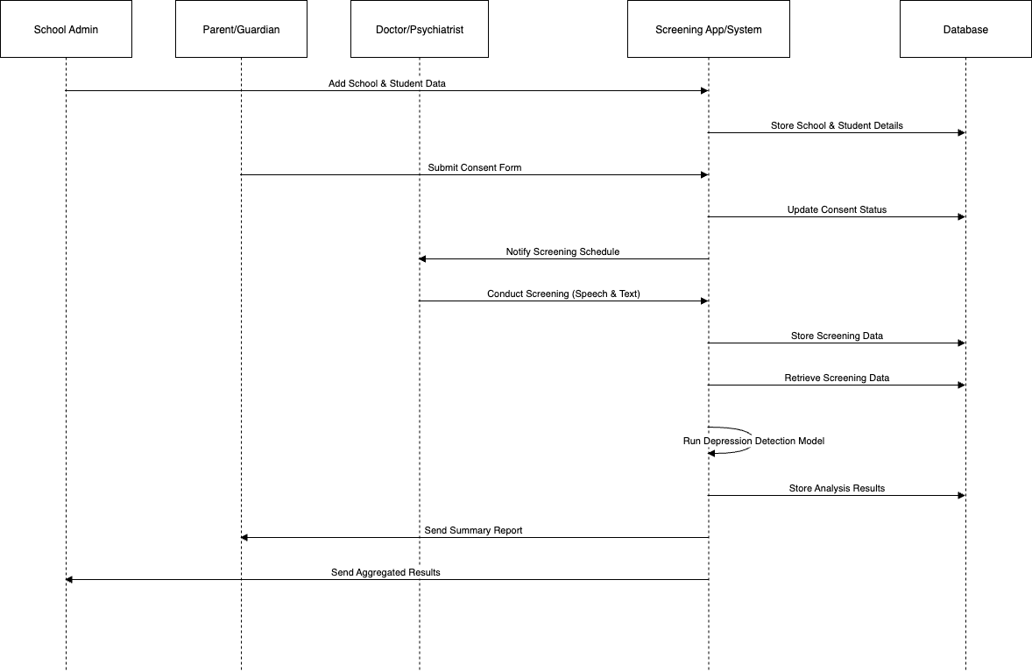

4. Key Components & Responsibilities

Auth Service
- OAuth2 + JWT for authentication.
- Support SSO for internal Smile Stars staff.
- Role-based access control (Central team, Franchisee Admin, School Admin, Doctor, Parent).
- Multi-factor authentication for central/admin users.

Org & User Service
- CRUD for Organizations: Franchisee, School, Branch.
- User profiles for parents, teachers, dentists, technicians.
- Consent document management and MOU attachment tracking.

Camp Management Service
- Create/Update/Delete camps.
- Approval workflow state machine (Draft → Pending Approval → Approved → Scheduled → Completed).
- Auto-generation of schedules and material lists based on student counts and days.

Screening Service
- QR code scanning endpoints.
- Screening form storage & attachments (images, prescriptions).
- Offline sync support for doctors (local DB + sync queue).

Content Service
- Multilingual content storage (text, audio, video, images).
- CDN + streaming support for media.
- Versioning for content updates.

Notification Service
- Queue-based notifications via SMS, Email, WhatsApp, Push.
- Template management and localization.

Reporting Service
- Aggregate attendance, screening counts, issues found, prescriptions.
- Scheduled PDF generation for reports and dashboards.

Background Workers
- Heavy tasks: PDF/ID generation, batch notifications, exports, analytics aggregation.

5. Data Model (High-Level)
- Organization: id, name, type(franchise/school/branch), address, contact
- User: id, org_id, role, name, email, phone, encrypted_identifiers
- Student: id, school_id, name, dob, parent_ids, consent_status, qr_id
- Camp: id, school_id, franchisee_id, start_date, end_date, status, estimated_students
- ScreeningRecord: id, student_id, camp_id, doctor_id, findings, prescription, timestamp
- ContentItem: id, title, language, type(video/audio/text/image), storage_path

6. Non-Functional Requirements & Considerations
- Security & Compliance
  - Encrypt PII at rest and in transit (TLS + DB encryption).
  - Role-based access control and audit logs for sensitive actions.
  - Comply with Indian DPDP/DPB regulations and local privacy laws.
- Scalability
  - Microservice architecture with horizontal scaling.
  - Use managed DB with read replicas for heavy read loads (reporting).
- Offline Support
  - Mobile apps (Doctor/Franchisee) must support offline data capture with local queueing and conflict resolution on sync.
- Resiliency
  - Retry strategies in worker queues, circuit breakers for external services.
- Performance
  - Target <200ms API response for common endpoints (fetch student, scan QR).
- Monitoring & Observability
  - Centralized logging (ELK), metrics (Prometheus), error tracking (Sentry).

7. Implementation Notes & Prioritization (MVP Focus for 3 months)
MVP (Phase 1 - must have for launch)
- Central web portal core: franchisee management, camp approvals.
- Franchisee web/mobile: create schools, branches, camps.
- School: student registration & consent upload.
- QR generation & scanning + offline doctor app sync.
- Notification integration for SMS and WhatsApp (emails optional initially).
- Background worker for ID PDF generation and schedule/material calculation.
Phase 2 (post-launch)
- Full multilingual content portal with streaming & downloads.
- Payment gateway (if required).
- Advanced reporting dashboards and analytics.
- Integrations with government health systems (if needed).

8. Security & Privacy Checklist
- TLS everywhere.
- Encrypt sensitive fields (Aadhaar, if ever collected, must follow strict policy — avoid unless necessary).
- Consent capture must be tamper-evident (store signed PDF, upload timestamp, source).
- Audit logs for approvals, consent changes, and data exports.

